PROBLEM FORMULATION
3.1 Introduction
Many optimization techniques were applied to solve the optimal DGs and capacitors placement problem. Esmaili et al. [10] presented the optimal locations and sizes of DGs to enhance voltage stability and to reduce system losses simultaneously. The optimal locations of DGs were determined based on vulnerable buses from voltage stability point of view using bifurcation analysis. Then, the dynamic programming search (DPS) method was used to find the optimal sizes of DGs. Gözel and Hocaoglu [11] introduced the optimal locations and sizes of DGs so as to minimize total power losses by an analytical method using a loss sensitivity factor based on the equivalent current injection in the distribution systems. Devi and Geethanjali [12] used the modified bacterial foraging optimization (MBFO) algorithm to find the optimal locations and sizes of DGs to reduce the total power loss and to improve the voltage proﬁle in radial distribution systems. However, only DGs at unity power factor were considered. Biswas et al. [13] used the GA to find the optimal locations and sizes of DGs to reduce the line loss, the voltage sag and the total cost of DGs as a multi-objective function. However, only DGs at unity power factor were considered.
In [14], two-stage method was used to solve the optimal capacitors placement problem based on the loss sensitivity factors to determine the optimal locations and the plant growth simulation algorithm (PGSA) to estimate the optimal sizes of capacitors. However, the optimal solution may be not obtained because the optimization technique is restricted only to find the sizes of capacitors. In [15,16], the fuzzy approach was used to find the optimal locations of capacitors. Then, the bacteria foraging algorithm (BFA) was utilized to find optimal sizes of capacitors in [15], while the genetic algorithm (GA) was employed to find the optimal sizes of the capacitors in [16]. In [17], the authors presented power loss index (PLI) to determine the high potential buses for capacitors placement. Then, the optimal sizing and placement of capacitors were obtained using accelerated particle swarm optimization (APSO) technique.
Devi and Geethanjali [22] used the PSO to find the optimal locations and sizes of DGs and distribution static compensator (DSTATCOM) for power loss reduction in radial distribution systems. However, a single objective function and DGs at unity power factor were considered. Selvi [23] presented the optimal locations and sizes of DGs and capacitors to reduce the system losses. First, the suitable locations for placing DGs and capacitors were identified through loss and voltage sensitivity factors. Then, the fuzzy adaptation of evolutionary programming (Fuzzy-EP) was used to find the optimal sizes of DGs and capacitors. However, DGs at unity power factor was considered.
3.2 Problem Formulation
3.2.1 Objective function
One of the main benefits of optimal DGs and capacitors placement in distribution systems is to minimize the real power loss. Mathematically, the real power loss can be expressed as [23]:
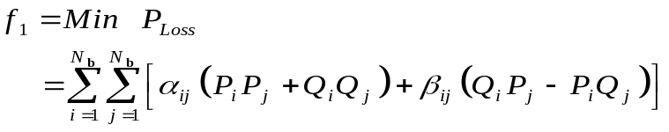 (3.1)
where,
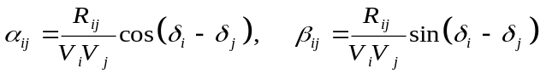
where, P_{Loss} is the total real power loss to be minimized, P_{i} and Q_{i} are the net active and reactive power at bus i, respectively. V_{i} and V_{j} are the voltage magnitudes at buses i and j, respectively. δ_{i} and δ_{j} are the phase angle of the voltages at buses i and j, respectively. R_{ij} is the line resistance between buses i and j. N_{b} is the number of system buses.
3.2.2 System constraints
The above mentioned single objective function in Equation (3.1) is subjected to the following constraints:
3.2.2.1 Equality constraint
- Load balancing constraint
For each bus, the following load balancing equations must be satisfied:
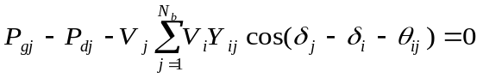 (3.2)
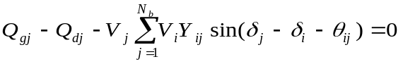 (3.3)
where, P_{gj} and Q_{gj} are the active and reactive power output from the generator at bus j, respectively. P_{dj} and Q_{dj} are the active and reactive power demand at bus j, respectively. V_{i} and V_{j} are the voltages at sending end i and receiving end j, respectively. Y_{ij} and θ_{ij} are the admittance magnitude and angle between buses i and j, respectively. δ_{i} and δ_{j} are the phase angles of voltages at buses i and j, respectively.
3.2.2.2 Inequality constraints
- Bus voltage constraint
The voltage at each bus (V_{i}) must be within its permissible minimum and maximum limits as:
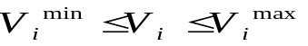 (3.4)
- Overall Power factor constraint
The overall system power factor (pf_{overall}) must be greater than or equal to the minimum limit of overall power factor (pf ^{min}) as:
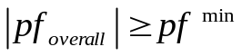 (3.5)
- Number of DGs constraint
This constraint aims to reduce the number of DGs placement. Therefore, the optimal number of DGs (N_{DG}) must be less than or equal to the maximum number of possible locations (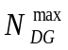) as:
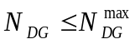 (3.6)

- Number of capacitors constraint
This constraint aims to reduce the number of capacitors placement. Therefore, the optimal number of capacitors (N_{C}) must be less than or equal to the maximum number of possible locations (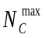) as:
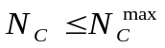 (3.7)
- DG size constraint
The active and reactive power injections by DGs must be within their permissible minimum and maximum limits as:
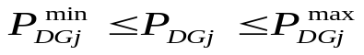 (3.8)
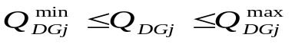 (3.9)
where, P_{DGj} and Q_{DGj} is the active and reactive power injections by DGs at location j, respectively.
- Capacitor size constraint
The reactive power injection by capacitors must be within its permissible minimum and maximum limits as:
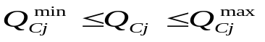 (3.10)
where, Q_{Cj} is the reactive power injection at location j.
- Total active and reactive power constraints
The total active and reactive power injections by DGs (P_{DG}^{Total},Q_{DG}^{Total}) and the total reactive power from capacitors (Q_{C}^{Total}) must be less than or equal to the total load active and reactive power (P_{L}^{Total}, Q_{L}^{Total}) as:
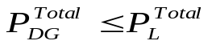 (3.11)
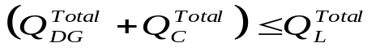 (3.12)

